A picture containing clipart

Description generated with very high confidence

Azure 103 Module 4

Hands On - 2

Azure Certification Training

[**support@intellipaat.com**](mailto:support@intellipaat.com)

**+91-7022374614**

**US: 1-800-216-8930(Toll Free)**

**Azure 103 Module 4 , Hands On – 2**

**Create and configure VNet to VNet peering.**

**Step 1:** Create Two VNets in the same region named VNet1 and VNet2.

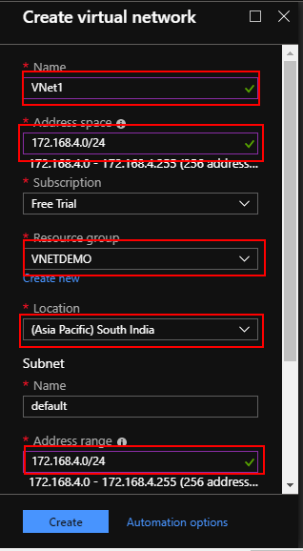

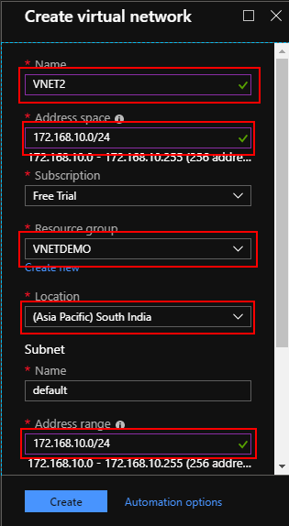

**Step 2:** Create two virtual machines (Windows Datacenter 2016) named VM1 and VM2. One in each VNet created in step 1. Make sure to enable all protocols for connecting to VM's.

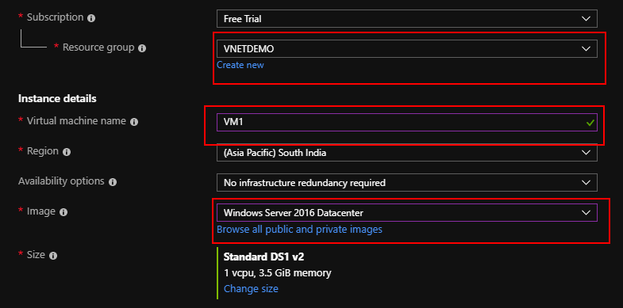

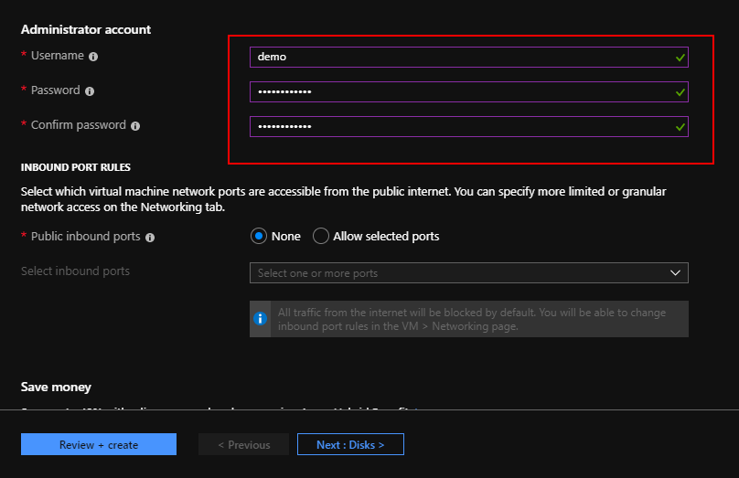

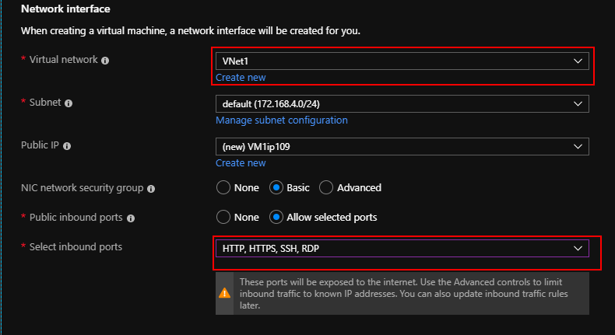



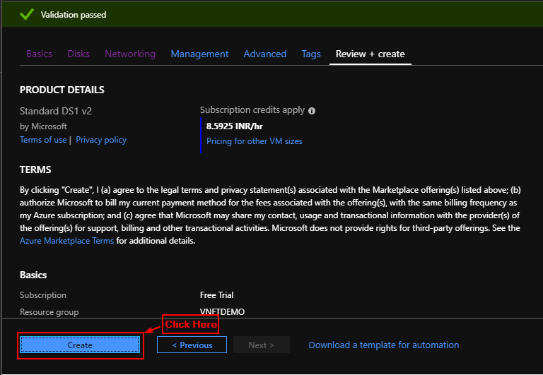

**Step 3:** Open Virtual Network and click on VNet1.

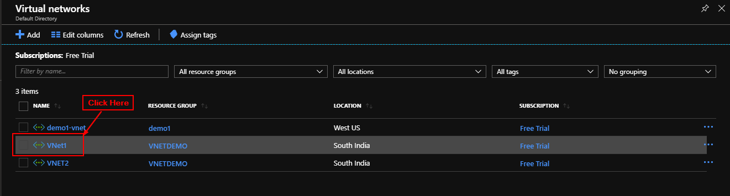

**Step 4:** From the sidebar select Peerings.

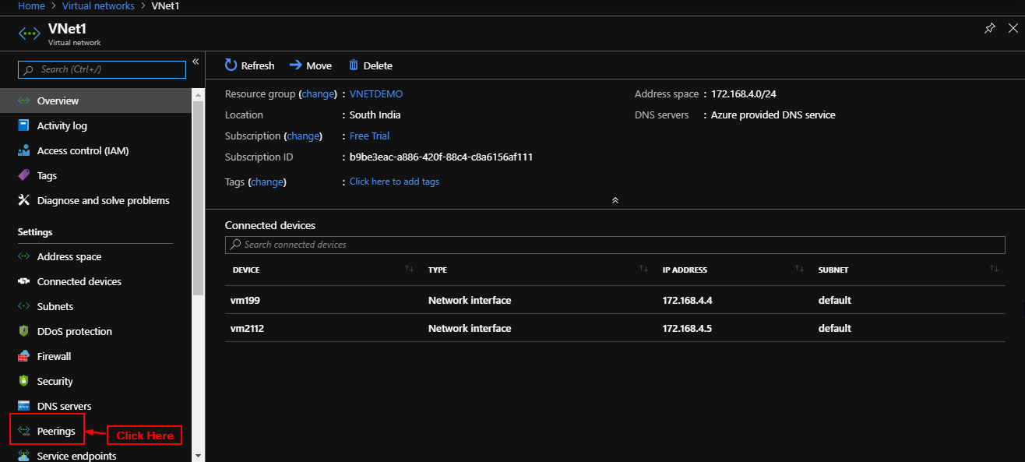

**Step 5:** Click on add.

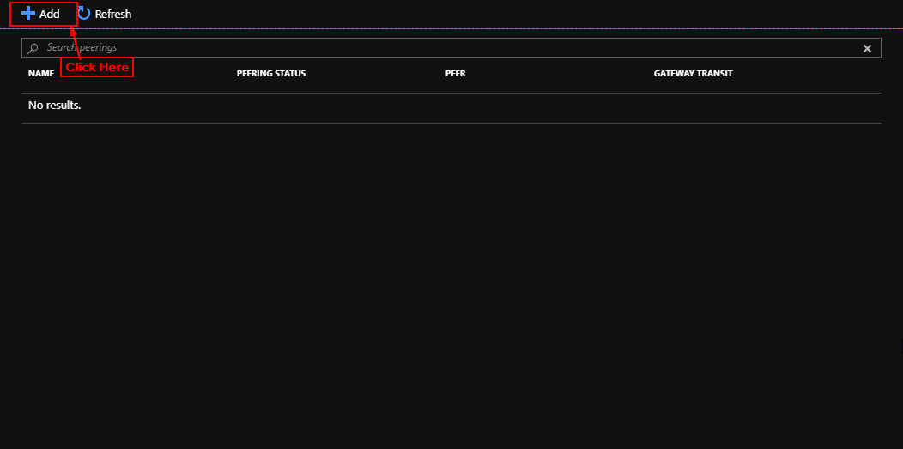

**Step 6:** Enter Details add names to both peering from VNET1 to VNET2 and VNET2 to VNET1 and click on OK.

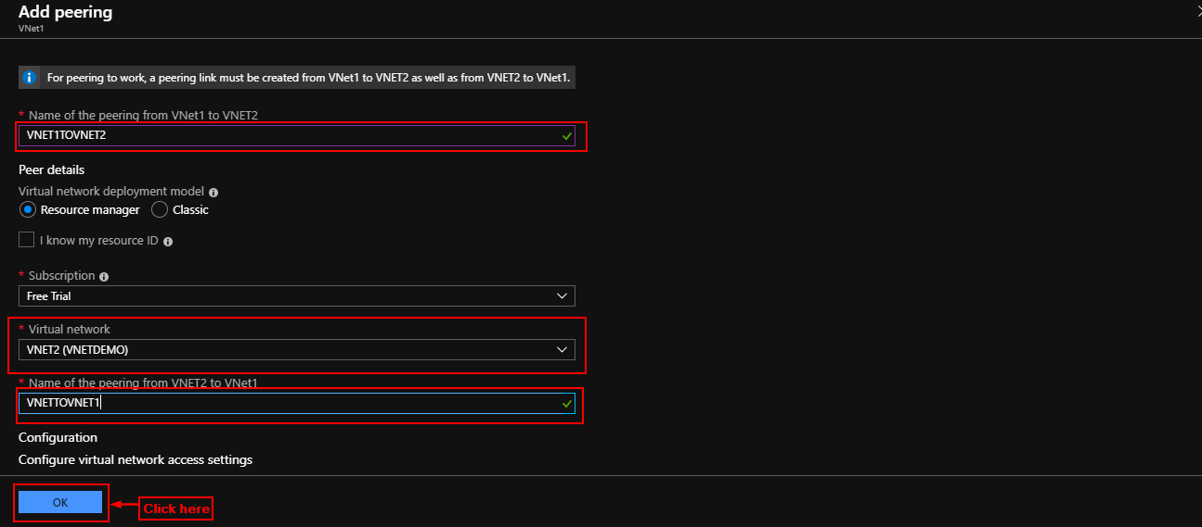

**Step 7:** Two Peerings (Bi Directional) will be added (Check in both VNET1 and VNET2).

